Project Overview:
This project focuses on designing and implementing a scalable, end-to-end data warehousing solution for a financial institution using Azure Synapse Analytics, Azure Data Lake Storage Gen2, and Power BI. The goal is to consolidate customer transaction data from raw files into a structured format to enable efficient reporting, analytics, and business insights.
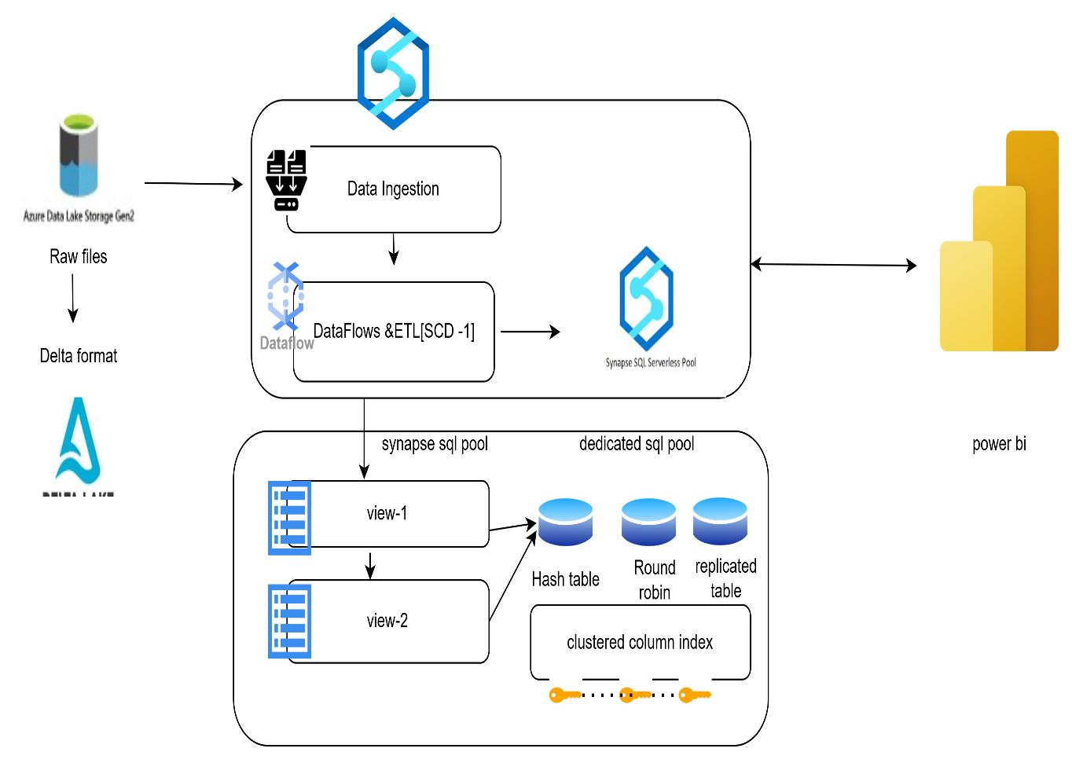
The dataset was taken from the Kaggle
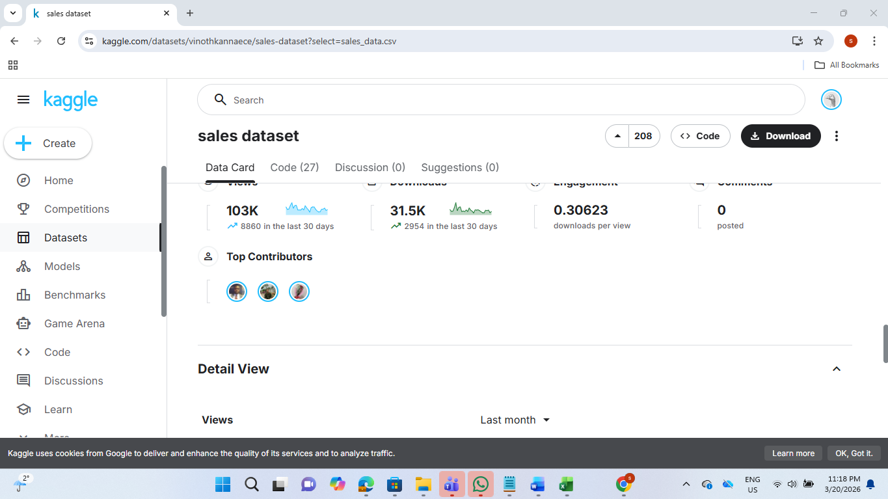
Download the dataset
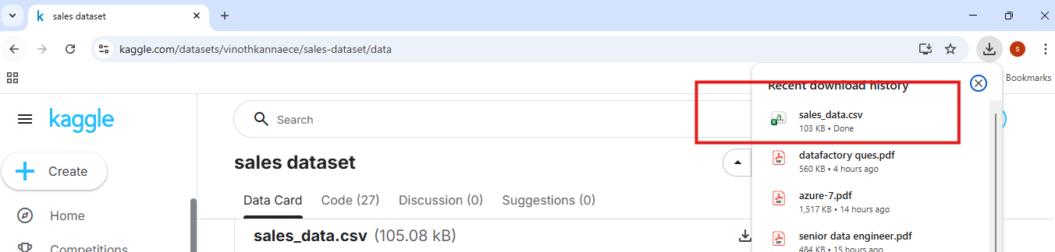
Step-1: upload the file to ADLS Gen2
Upload the file
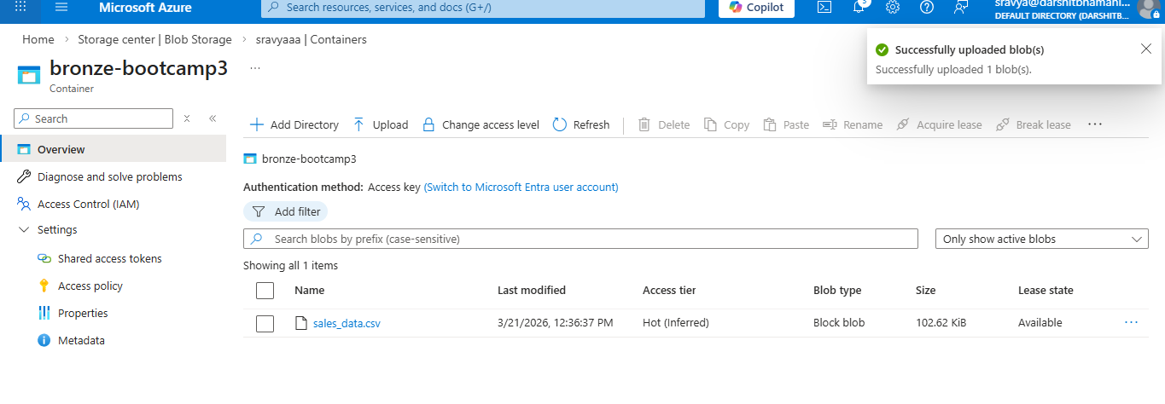
STEP 2: Convert CSV → Delta (Dataflow)
Open the Synapse Studio
create dataflow
Go to Develop → + → Dataflow
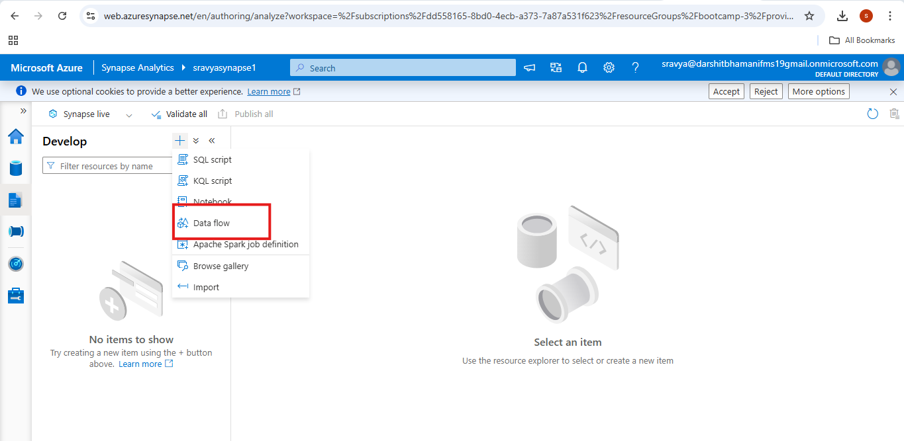
Create the source
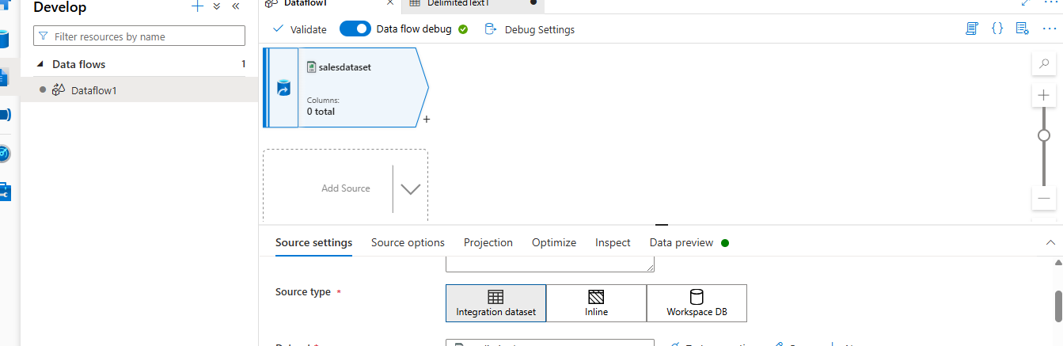

Open the source settings
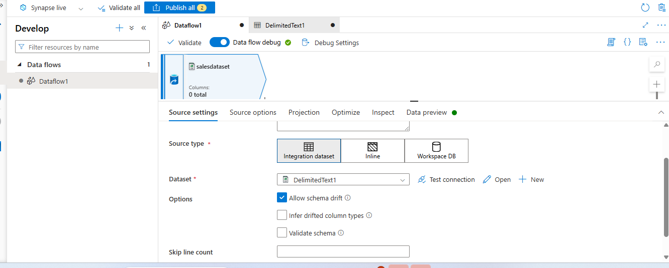
Create the linked service
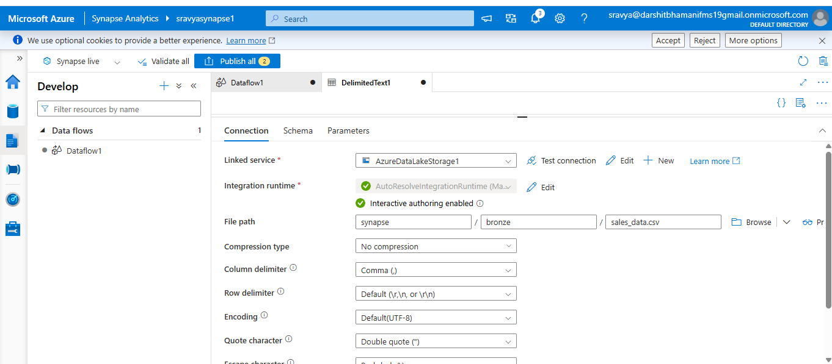

Select the path of the file
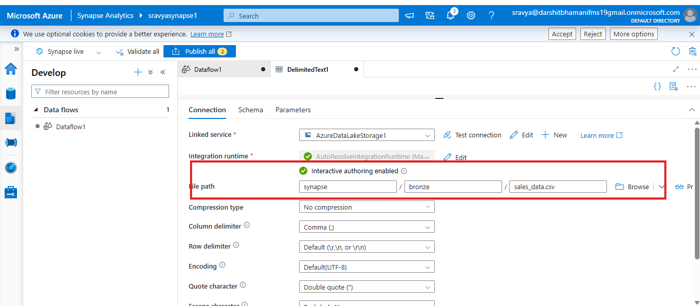
Data can be previewed
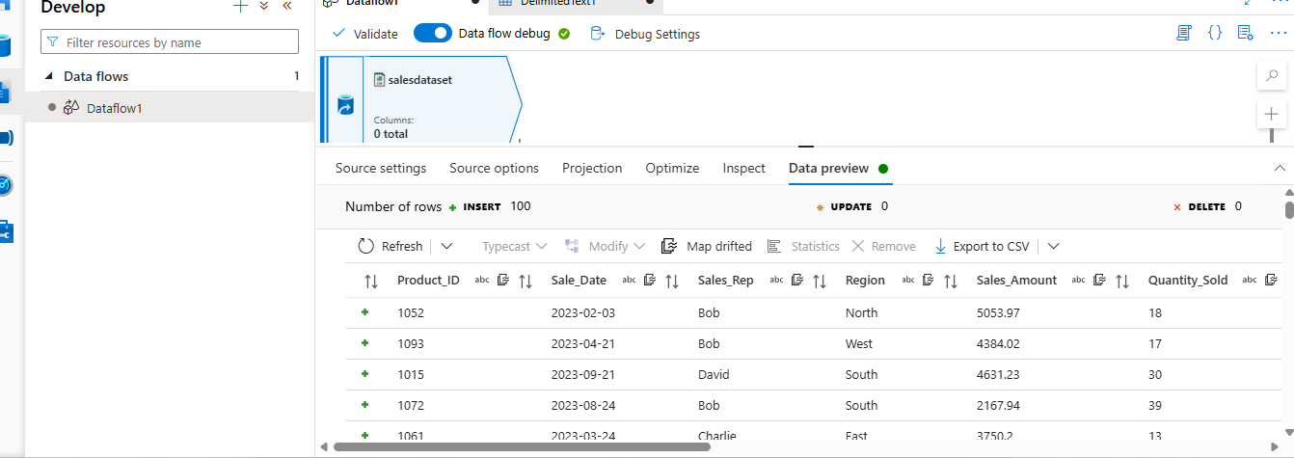
Step-2) Convert data into delta format using dataflows
Create the container
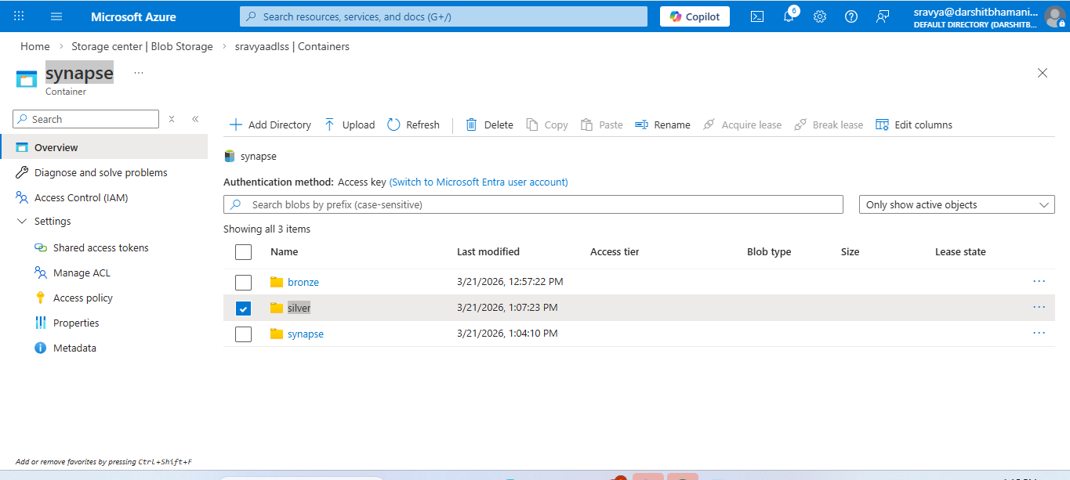
Create the sink
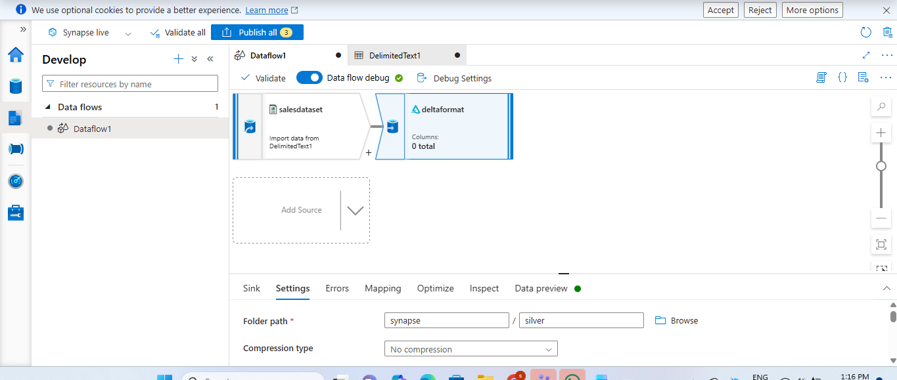
Choose a format with a delta
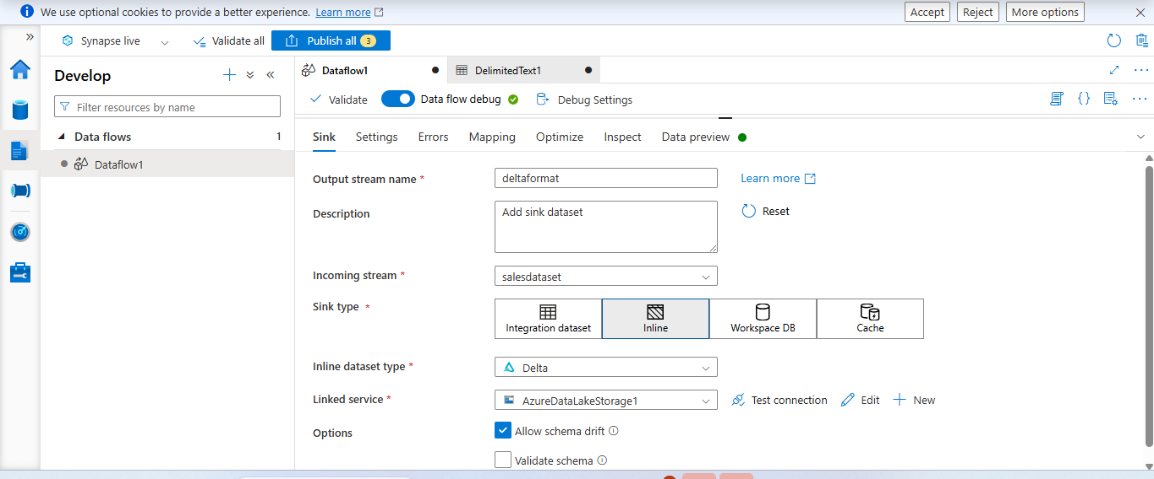
Give the folder path and file path
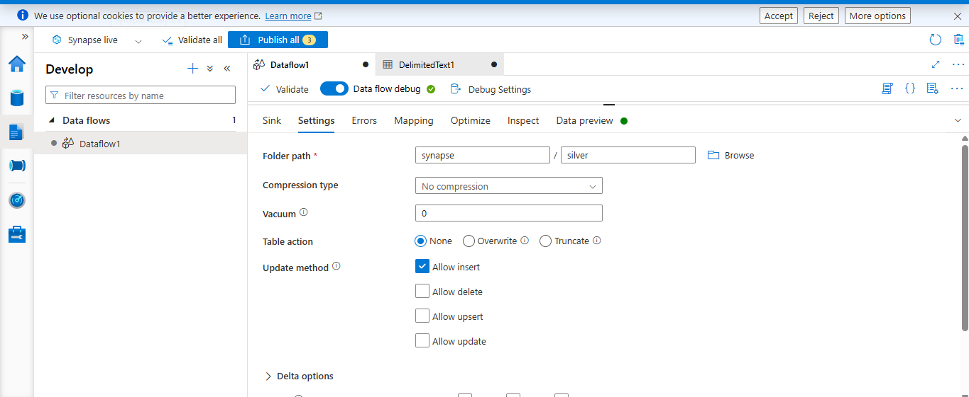
Click on data preview
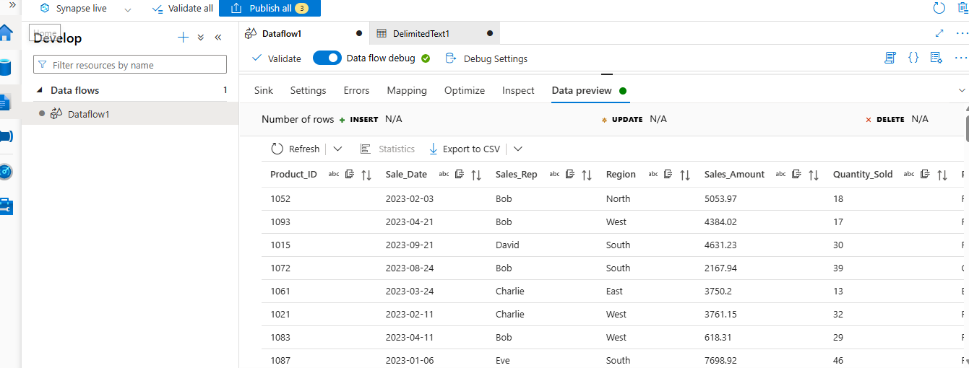

Create a pipeline
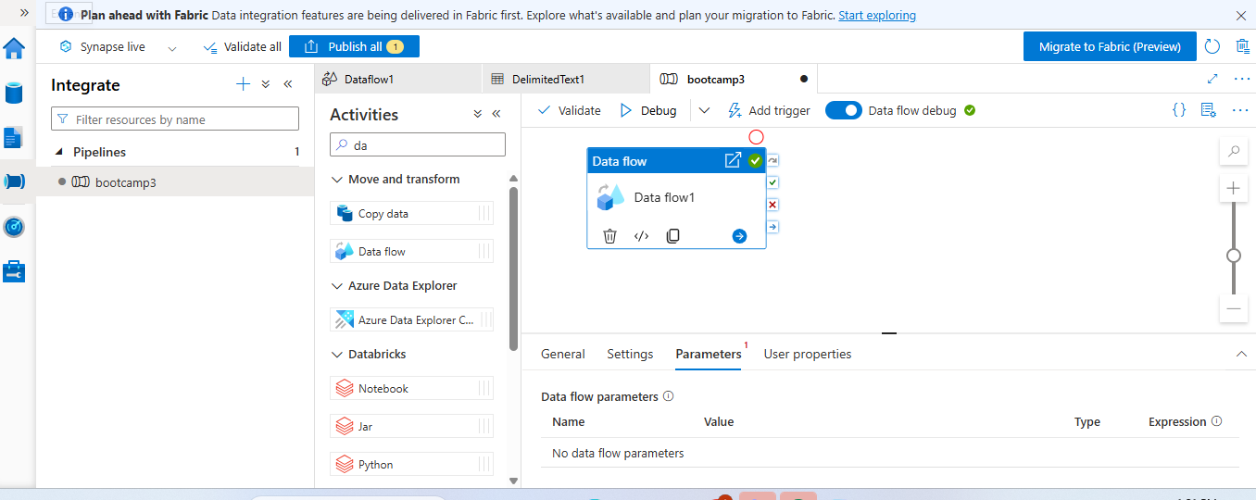
Select the dataflow activity
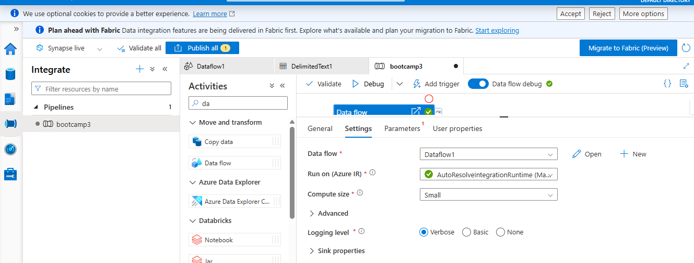
Pipeline got succeeded
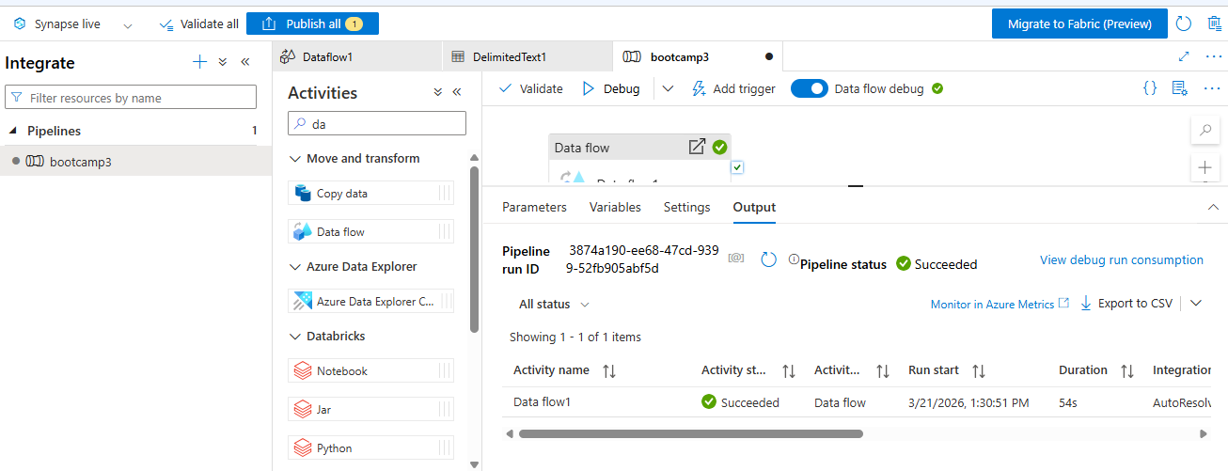
Click on preview
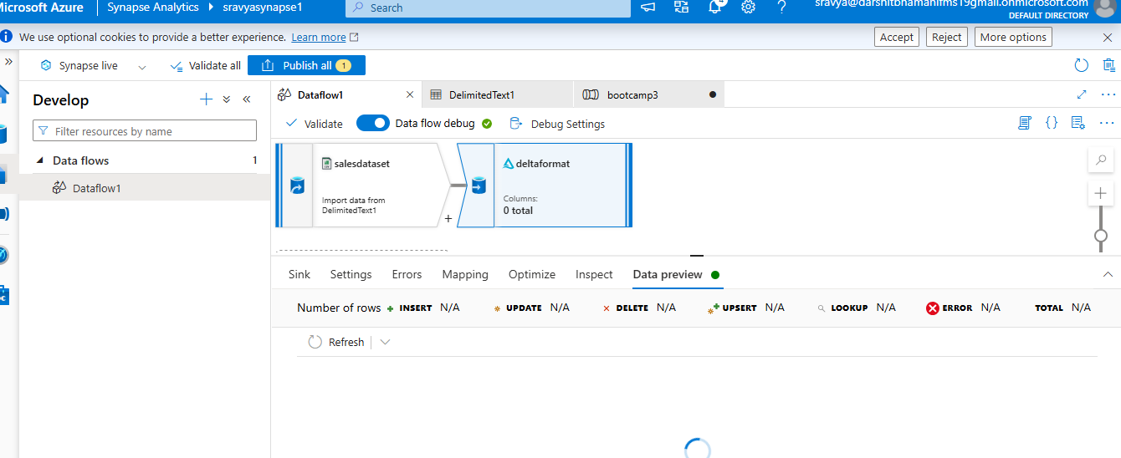
Output data is copied in sink:
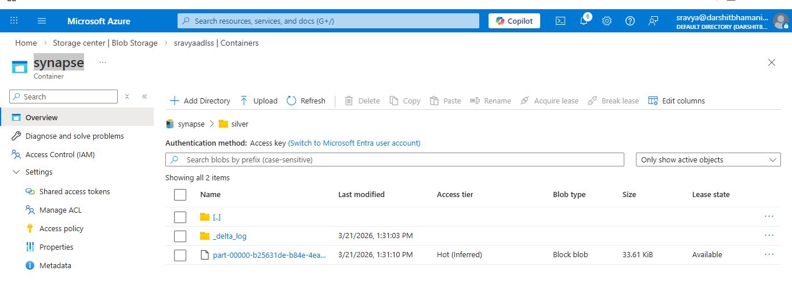

Step-3: Using dataflows, convert 1 table to SCD Type 1. Store in delta format in ADLS Gen2. Query the data from the SCD type 1 table using the serverless SQL pool.
SCD (Slowly Changing Dimension) Type 1 is a data warehousing technique where existing records are directly updated with new values whenever changes occur, without preserving any historical data. This approach ensures that only the most current and accurate information is stored in the system, making it simple and efficient for scenarios where tracking past changes is not required. It typically uses overwrite or upsert logic based on a key column (such as customer_id) and is commonly applied to attributes like contact details or product prices, where only the latest value matters.

Need to modify the existing workflow
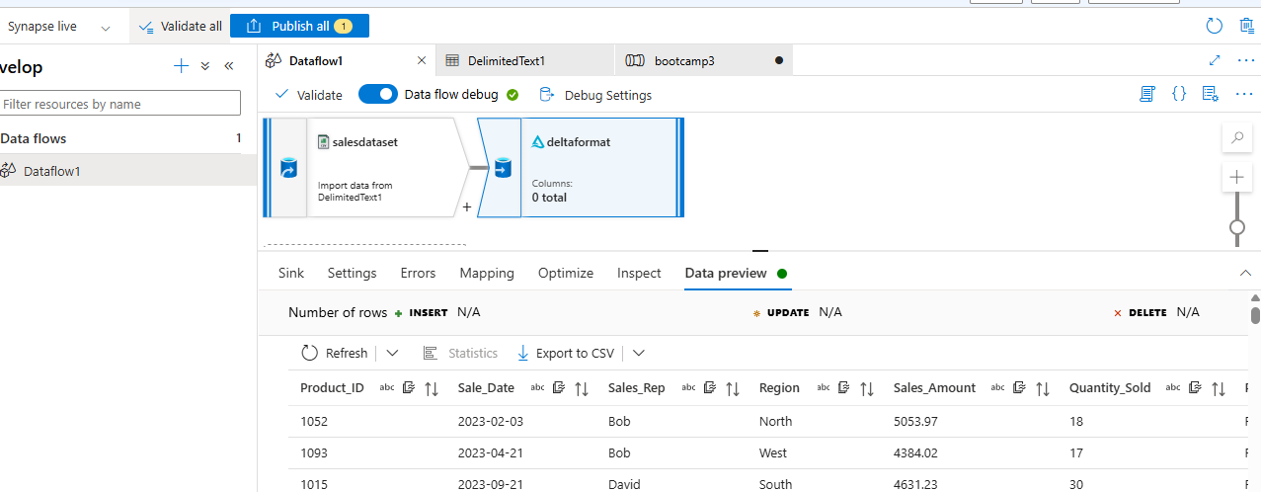
Add the Alter Row
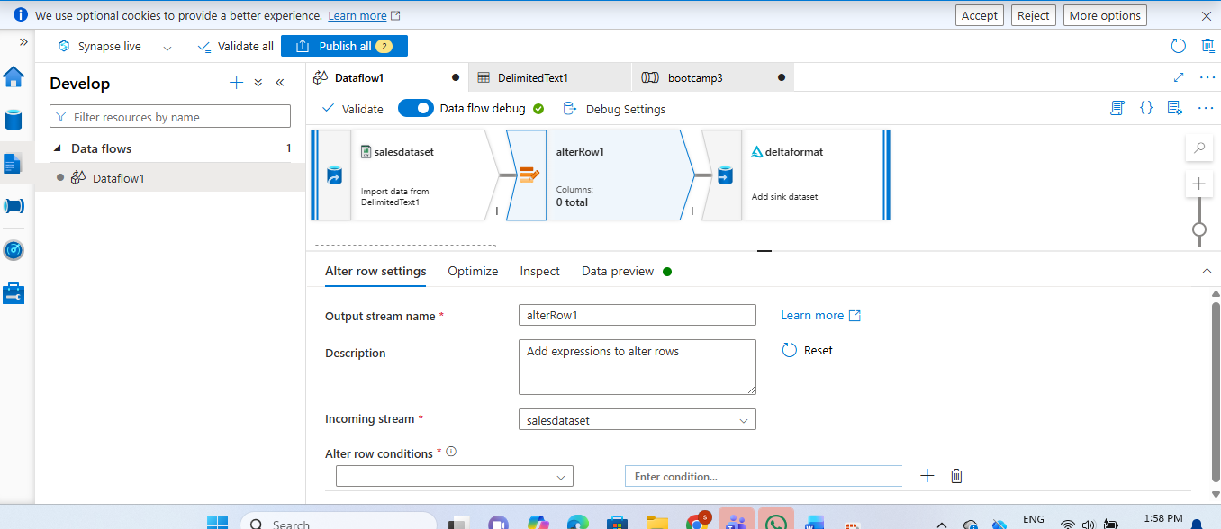
Add the below conditions
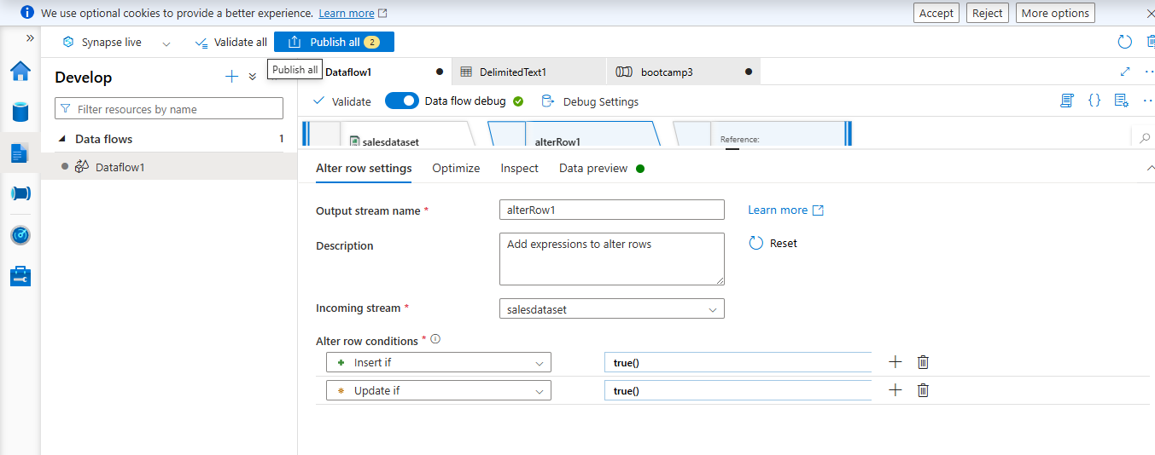
Data will appear like this
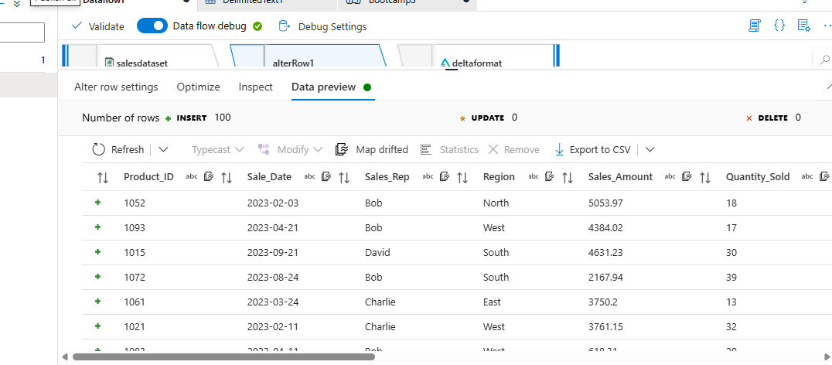
In the sink choose upsert
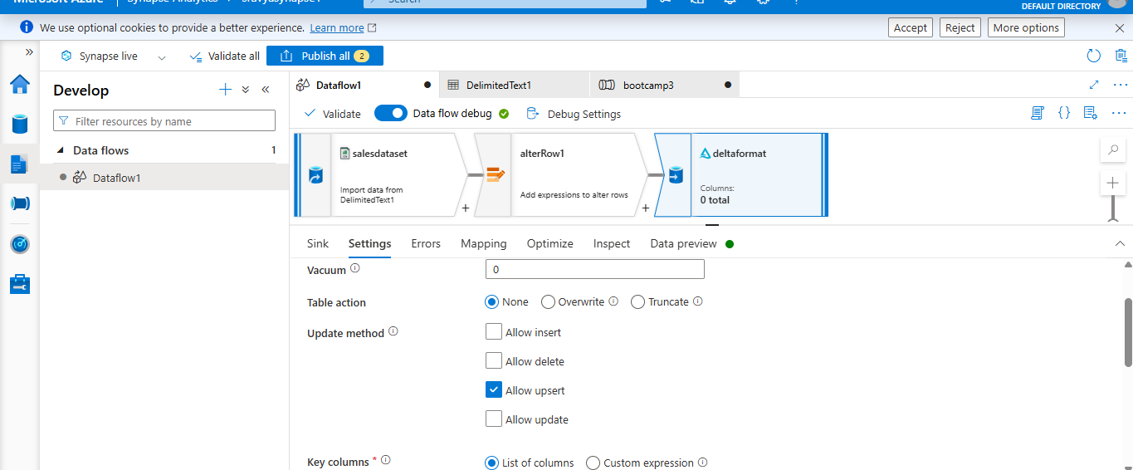
List of columns select the below
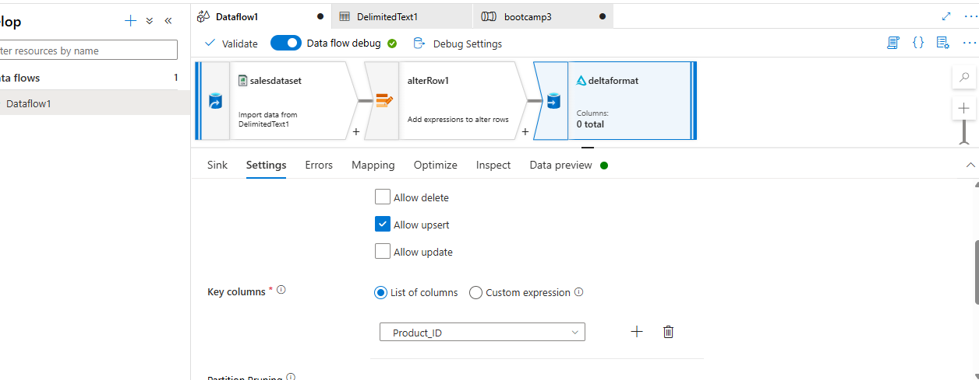
Preview the data
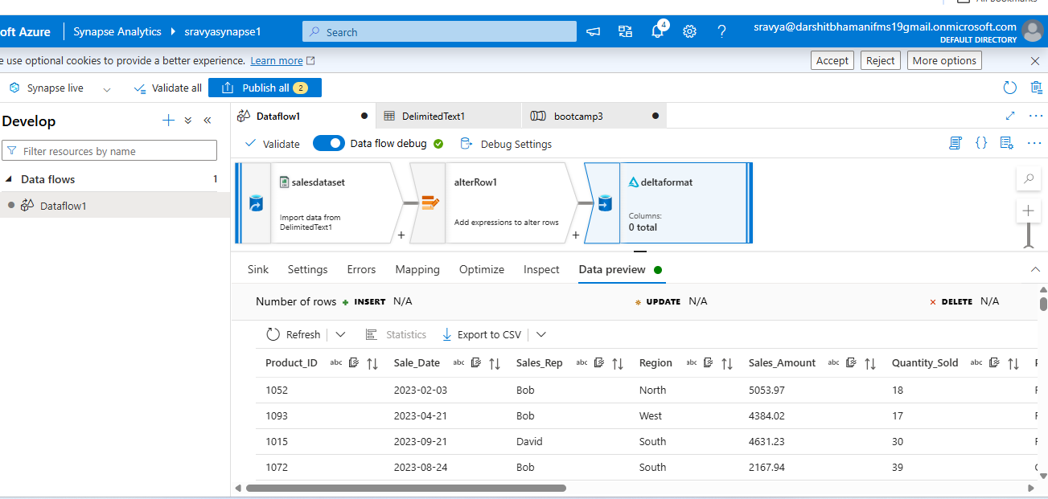
Add the windows function
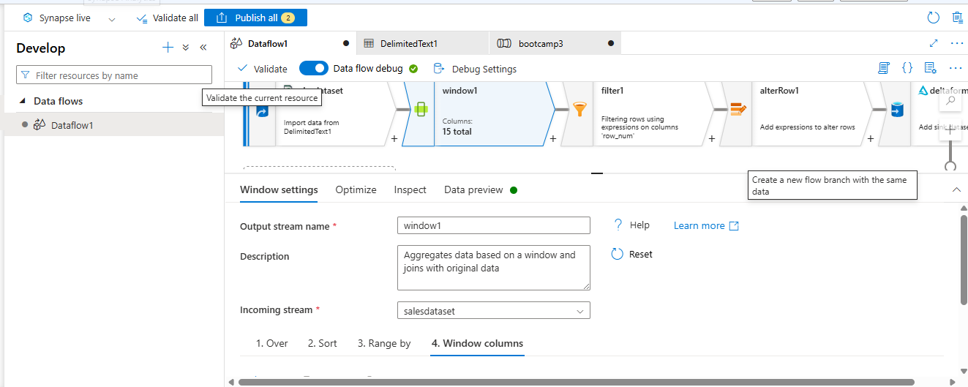
Over by should be
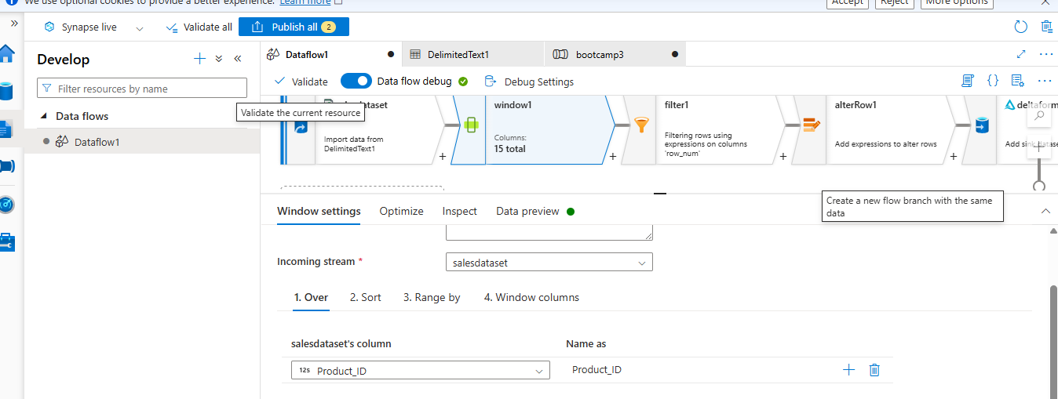
And the sort
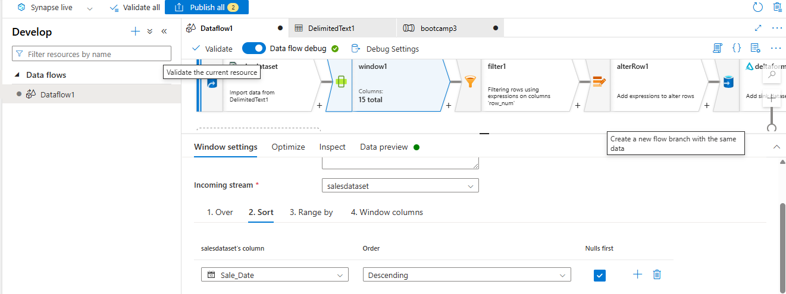

And fill the window functions
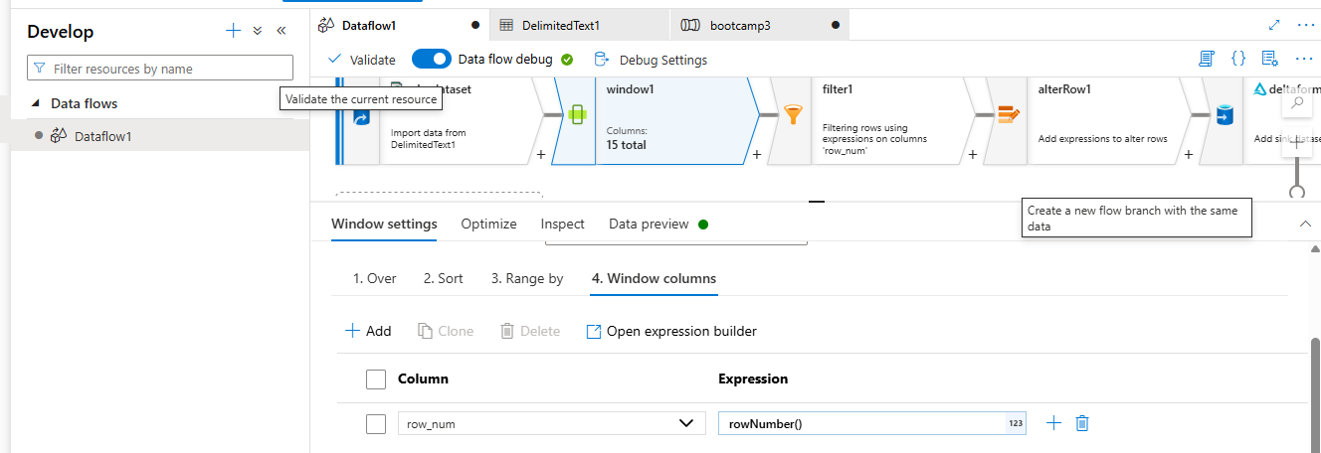

Add the filter condition
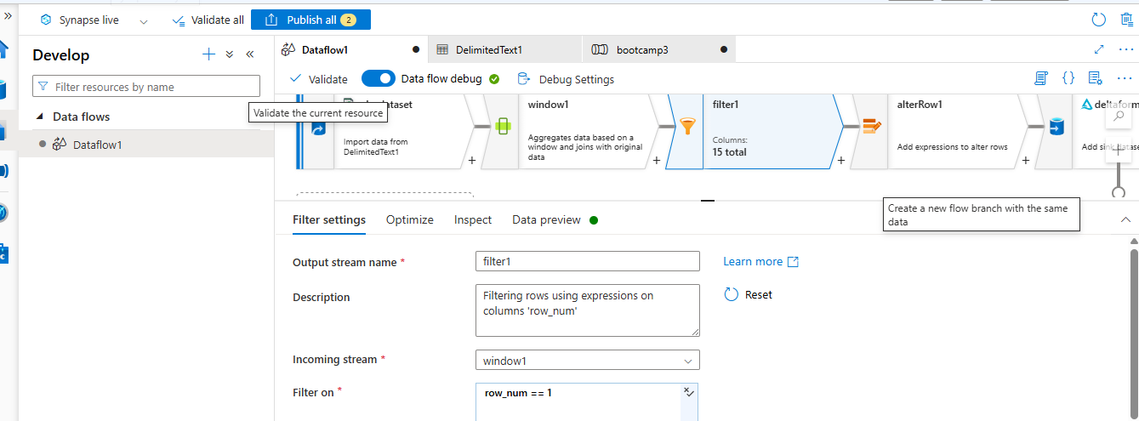
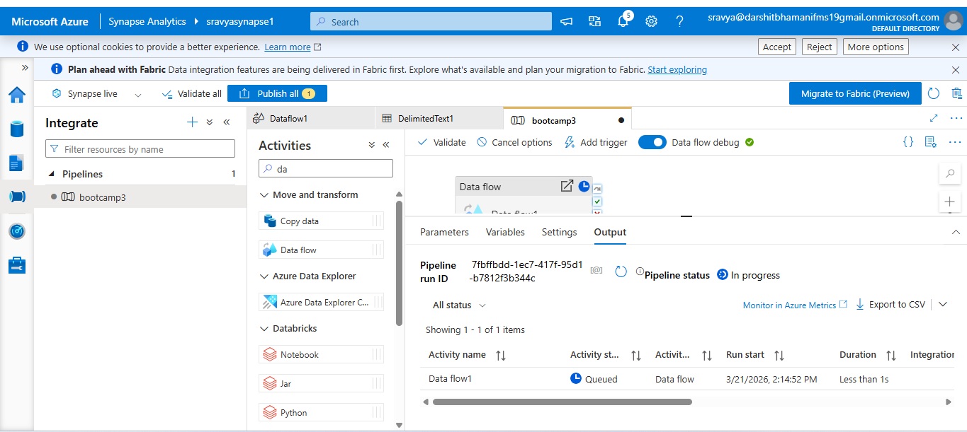
Click on debug

The pipeline was running

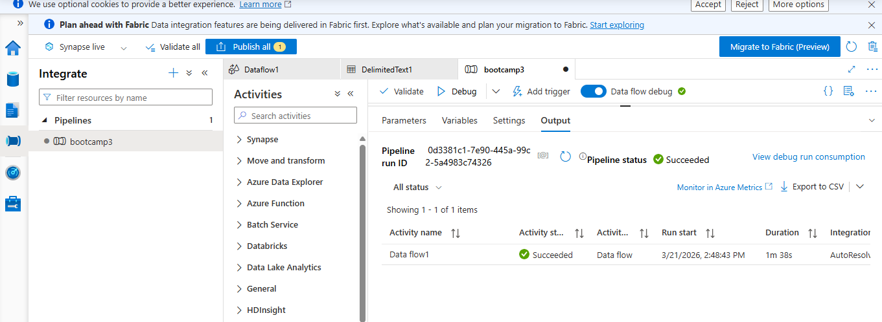
Output:
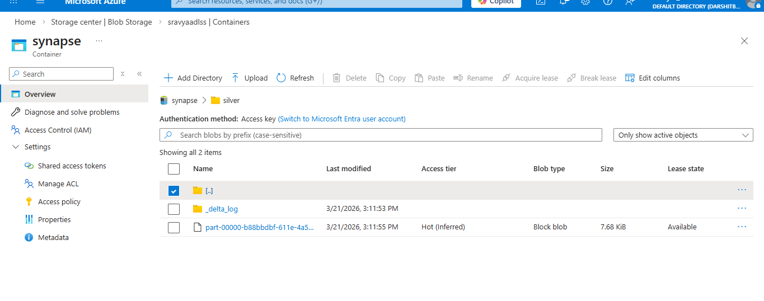
Querying the data using serverless sql pool
Create the external data source
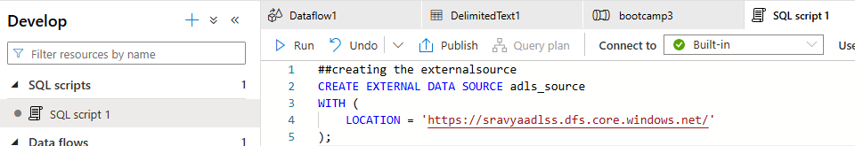

Query the data from scd-1
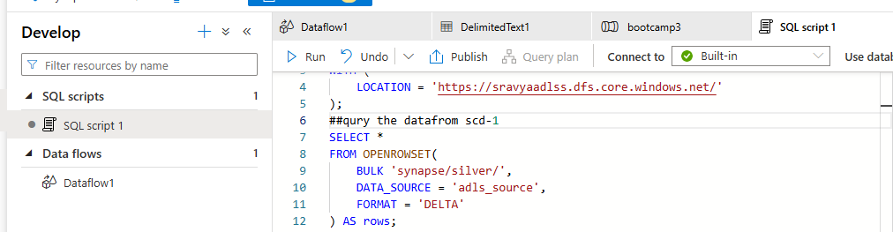
Checking the duplicates
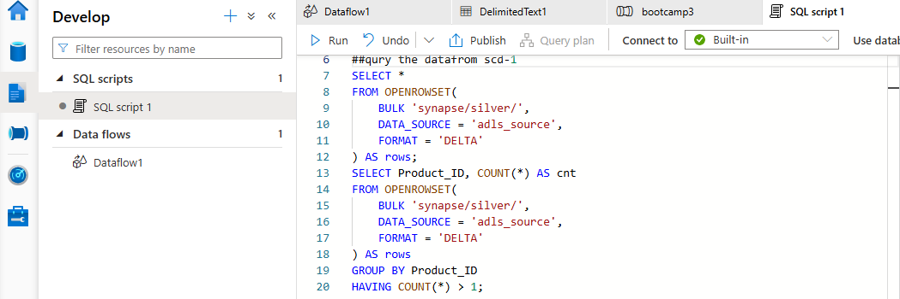

Creating the view
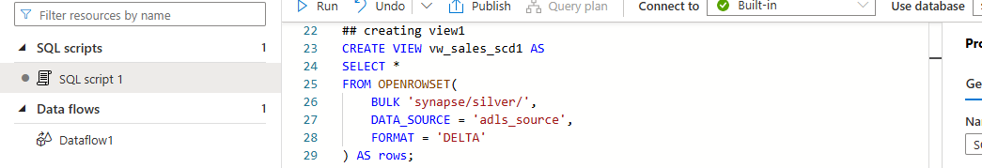
Creating another view
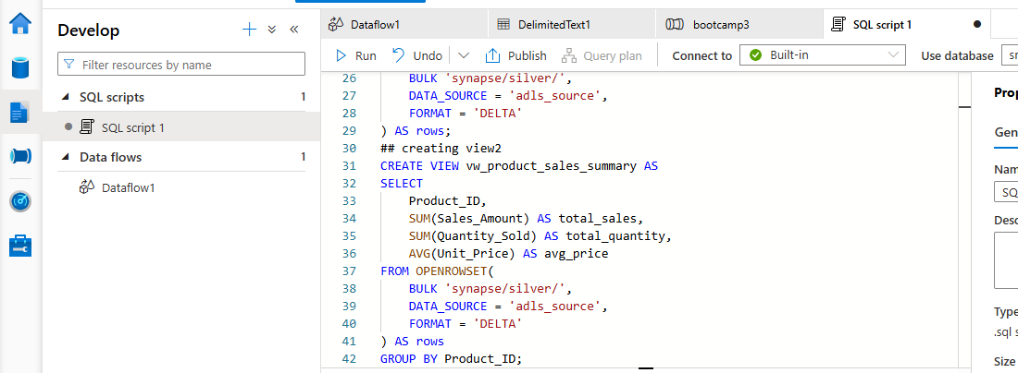
Creating the dedicated SQL pool:
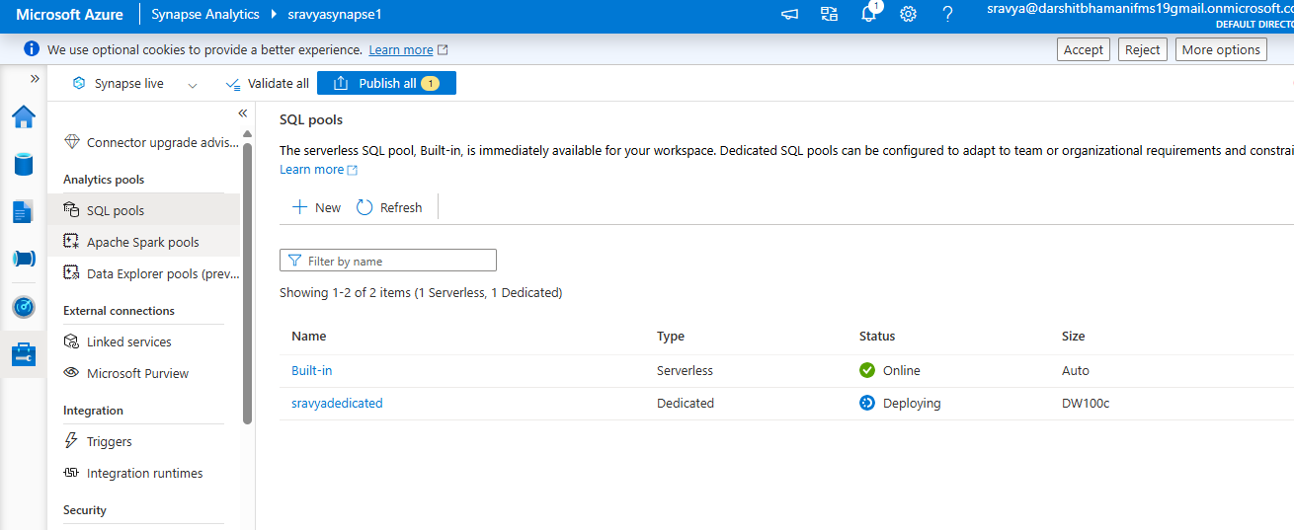

Fill in all the details, wait for deployment
Dedicated pool was created
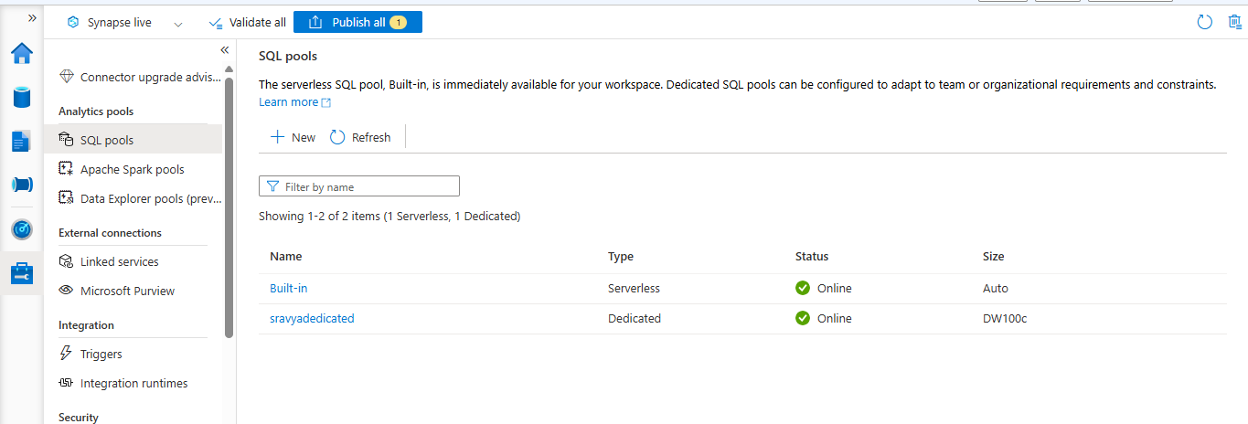
Created the hash distribution for the customer table
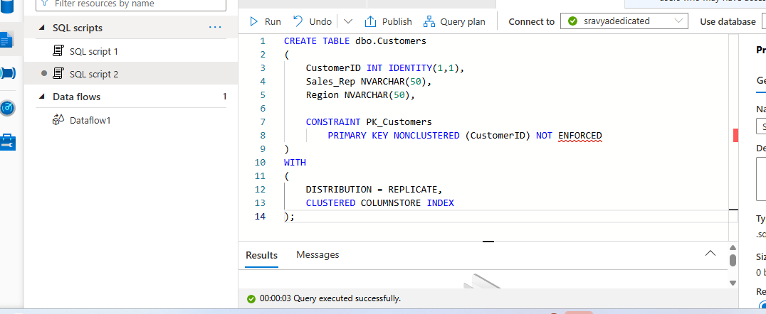
Created the round robin distribution
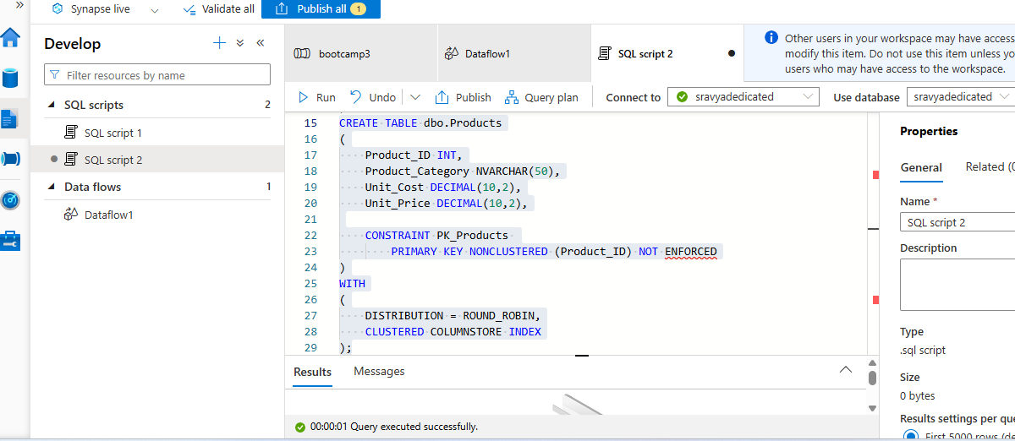

Created the hash table
